Nombre: __________________________ Bloque: ____________ Fecha: ______________________
Español 2 – Unidad 5 – Guía de estudio
1. Temas:
- Be able to talk about preparing food dishes and food flavors and ingredients.
- Be able to order food and have a conversation in a restaurant.
- Be able to formal commands.
- Be able to use direct and indirect object pronouns correctly with commands and in other types of sentences.
- Be able to make both affirmative and negative sentences and the superlative form of adjectives.
- Be able to describe culturally relevant and important food dishes from Spain.
- Discuss the culture of Spain.

2. Partes del examen:

Listening Test Section – 50%
For the listening test, you will hear various styles of listening samples in Spanish related to the vocabulary and grammar from this unit. These samples can range from conversations, advertisements, sentences, and monologues to completing dictations. Then you will have to answer comprehension questions about what you heard. These questions may be true or false statements, fill-in-the-blank statements, short answer questions, or multiple-choice questions. The listening sections will be similar to what we have practiced in class.

Reading/Vocabulary Test Section – 50%
For the reading test, you will have to read various styles of reading samples in Spanish related to the vocabulary and grammar from this unit. These samples can range from written conversations, advertisements, sentences, and paragraphs to short stories. Then you will have to answer comprehension questions about what you heard. These questions may be true or false statements, fill-in-the-blank statements, short answer questions, true/false, or multiple-choice questions. The reading sections will be similar to what we have practiced in class and/or to the readings found in the book and workbook. You should also review the vocabulary list from the current unit and the notes from the current unit in preparation.

3. Vocabulario:
El aceite | Oil (for cooking) | El flan | Custard
El ajo | Garlic | El gazpacho | Cold tomato soup
El azúcar | Sugar | La paella | Traditional Spanish rice dish
La cebolla | Onion | El plato vegetariano | Vegetarian dish
Las espinacas | Spinach | El pollo asado | Roasted chicken
La fresa | Strawberry | La tarta de chocolate | Chocolate cake
La lechuga | Lettuce | El té | Tea
El limón | Lemon (sometimes a lime) | La heladería | Ice cream shop
La mayonesa | Mayonnaise | La pastelería | Pastry shop (bakery)
La mostaza | Mustard | La cuchara | Spoon
La pimienta | Pepper | El cuchillo | Knife
La sal | Salt | La servilleta | Napkin
El vinagre | Vinegar | El tenedor | Fork
La zanahoria | Carrot | El vaso | Glass
El ingrediente | Ingredient | Batido(a) | Beaten
El supermercado | Supermarket | Cocido(a) | Cooked
El sabor | Flavor | Crudo(a) | Raw
Agrio(a) | Sour | Frito(a) | Fried
Caliente | Hot (temperature) | Hervido(a) | Boiled
Delicioso(a) | Delicious | Mezclado(a) | Mixed
Dulce | Sweet | Molido(a) | Ground
Fresco(a) | Fresh | La mantequilla | Butter
Picante | Spicy; hot (spiciness) | La lima | Lime (in Mexico – a lemon)
Sabroso(a) | Tasty | Poner en el horno | To put in the oven/bake
Salado(a) | Salty | Revolver (o-ue)/Mezclar | To stir; to mix
¡Qué asco! | How disgusting! | Cocinar | To cook
Añadir | To add | El mantel | Tablecloth
Batir | To beat | Una taza | A cup; a mug
Freír (e-i) | To fry | Una taza medidora | A measuring cup
Hervir (e-ie) | To boil | Un cuarto de taza | A quarter cup
Mezclar | To mix | Un tercio de taza | A third of a cup
Probar (o-ue) | To taste; to try | Una media taza | A half-cup
La receta | Recipe | Una cucharadita | Teaspoon (measure)
La tortilla de patatas | Potato omelet | Una cucharada | Tablespoon (measure)
Cenar | To have dinner | El plato | Plate
Desayunar | To have breakfast | Un bol; un tazón; un cuenco | A bowl
La merienda | Afternoon snack | Una sartén | A frying pan
¿Cuál es la especialidad de la casa? | What is the specialty of the house? | Una olla; una cacerola | A saucepan; a pot
¿Me puede traer…? | Can you bring me…? | El horno | The oven
Y para comer… | And to eat… | Cortar | To cut
Y para beber… | And to drink…. | Poner la mesa | To set the table
¡Buen provecho! | Enjoy! (Bon apetit!) | El camarero | Waiter
¡Excelente! | Excellent! | Una propina | A tip
Muy amable | Very kind | La cuenta | The bill
Muy atento(a) | Very attentive | El cocinero | The cook
Gracias por atenderme | Thank you for your service | El jefe de cocina | The chef
El caldo | Broth | Pedir (e-i) | To order food; to ask for
La chuleta de cerdo | Pork chop | Servir (e-i) | To serve
El entremés | Appetizer | Reservar | To reserve
Los espaguetis | Spaghetti | Dejar (una propina) | To leave (behind) (a tip)
La especialidad | Specialty | La comida está buena. | The food is (tastes) good.
El filete a la parrilla | Grilled steak | La comida está mala. | The food is (tastes) bad.
¿Para ti? | For you? | La comida es buena. | The food is good (for you).
Para mí… | For me… | La comida es mala. | The food is bad (for you).

4. Gramática:
Imperativo/Mandatos Formales: Meaning – ¡Hable usted! Speak!
Used only with USTED/USTEDES. Formal commands.

-AR Verbs:
Usted | Ustedes
-e | -en
-ER/IR Verbs:
Usted | Ustedes
-a | -an

Ejemplo – Hablar – to speak/talk:
Usted | Ustedes
¡Hable ud.! | ¡Hablen uds.!

Ejemplo – Escribir – to write:
Usted | Ustedes
¡Escriba ud.! | ¡Escriban uds.!

Irregulares:

Poner – to put:
¡Ponga ud.! | ¡Pongan uds.!

Decir – to say:
¡Diga ud.! | ¡Digan uds.!

Venir – to come:
¡Venga ud.! | ¡Vengan uds.!

Salir – to leave:
¡Salga ud.! | ¡Salgan uds.!

Hacer – to do/make:
¡Haga ud.! | ¡Hagan uds.!

Ser – to be (description, permanent):
¡Sea ud.! | ¡Sean uds.!

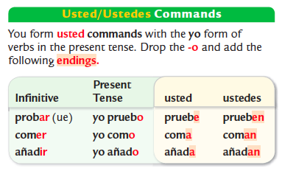
Ir – to go:
¡Vaya ud.! | ¡Vayan uds.!

Saber – to know (facts):
¡Sepa ud.! | ¡Sepan uds.!

Conocer – to know (people_:
¡Conozca ud.! | ¡Conozcan uds.!

Introducir – to introduce
¡Introduzca ud.! | ¡Introduzcan uds.!

Estar – to be (temporary):
¡Esté ud.! | ¡Estén uds.!

Dar – to give:
¡Dé ud.! | ¡Den uds.!
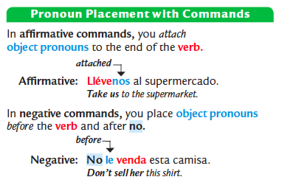

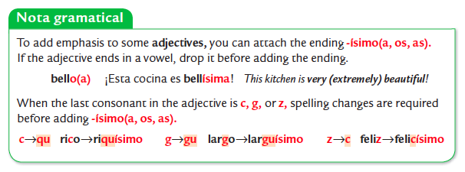

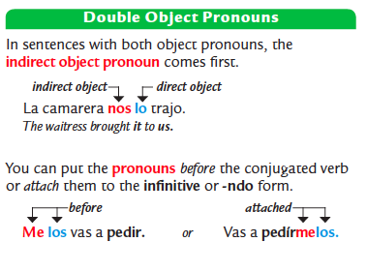
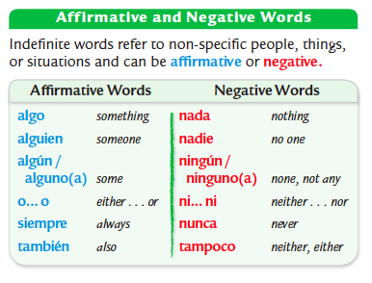

5. Cultura:
Please review your notes sheet on the cultural topics. While culture is not on the exam itself, it will be on a separate take-home quiz.
Datos generales y geográficos:
- Madrid is the capital of Spain.
- Languages: Spanish/castellano, Catalan/catalán, Basque/vasco, Galician/gallego, Asturian/asturiano
- Currency: Madrid uses the Euro along with the rest of the European Union.
- 2 Cities in Andalucía: Sevilla & Granada
- City in Cataluña: Barcelona
- Typical Foods: Gazpacho, Paella, Ensaladilla rusa

Las horas de comer:
- In Spain, many people eat a small breakfast between 7 and 9 am.
- They eat a large lunch between 1:30 and 3:30pm. Then may have a snack later between lunch and dinner.
- In Spain, many people don't eat dinner until 9 or 10 at night.
- In Spanish-speaking countries such as Spain, El Salvador and Uruguay, lunch is the main meal of the day.
- People in El Salvador generally eat dinner earlier than people in Spain, between 6-7pm.

Churros y porras:
- Churros and porras, both types of fried dough are sold in churrerías.
- People often also get a chocolate (caliente) drink that is very thick/rich and served with the churros or porras.

Las tapas:
- Tapas are small portions of food and are very common in Spain.
- Common tapas dishes include aceitunas (olives), el jamón, los calamares (squid) y los pulpos (octopus).
- Another common tapa is la ensaladilla rusa, which is a mix of potatoes, carrots, peas and mayonnaise.
- Another common tapa la torilla de patatas (tortilla española) which is different than tortillas from Mexico/Central America. A tortilla española is made with egg, potatoes and onion. A tortilla mexicana is made of flour or corn.
Typical Spanish Dishes:
- Paella is a traditional rice dish originating from valencia, Spain and is usually made with saffron, chicken, and shellfish.
- Gazpacho is a cold soup made of tomatoes and raw vegetables blended together.
- Flan is a dessert custard served with a caramel sauce.

Culinary Traditions:
Cultural Comparison – Madrid, Spain:
- El cocido madrileño is a dish/stew from Madrid, Spain made from chickpeas (garbanzos), vegetables, and meats. When served, the stock/soup, vegetables/chickpeas, and meats are all served separately.
- Sobrino de Botín is a restaurant in Madrid, Spain that serves traditional platos madrileños and is famous as the oldest restaurant in the world.

Cultural Comparison – Montevideo, Uruguay:
- Montevideo, the capital of Uruguay is located on the coast so fish and shellfish (pescado y mariscos) are alimentos básicos (basic foods) of the region and easy to find.
- La parrillada is a typical barbecue dish of meat roasted on a grill from the area of Montevideo.
- El Mercado del Puerto in Montevideo is a place you can go to eat lunch as it houses a number of different restaurants.

Toledo:
- Toledo, the capital of the province of Castilla-La Mancha is a historical city that has been protected since 1941 to limit modernization and industrial development.

El Greco:
- El Greco was the nickname of Doménikos Theotokópoulos, born in Greece/Grecía, but who became a famous artist in Spain.
- El Greco lived for many years in Toledo, Spain which is near Madrid.
- A famous painting by him is Vista de Toledo.

Antoni Gaudí:
- Antoni Gaudí was a famous catalán architect (arquitecto) from Barcelona, Spain in the region of Cataluña.
- Gaudí was a modernist and built decorative buildings and locations in Barcelona, drawing inspiration from nature and fantasy with bright colors and curving shapes.
- Some of Gaudí's famous works include: Casa Batlló, La Sagrada Familia, and Parque Güel.

La naturaleza muerta:
- La naturaleza muerta means a still life painting.
- La naturaleza muerta paintings contain inanimate, and things such as flowers, fruits, foods, plates, utensils, bread and instruments.
- Àngel Planells was an artist from Cataluña, Spain, and painted the above example of naturaleza muerta (a table with foods, a plate, glass, knife, napkin, etc).

Pablo Neruda:
- Pablo Neruda was a famous poet from Chile.
- Pablo Neruda wrote many odas/odes to various every day objects (las cosas más básicas de la vida).

Maria Blanchard:
- María Blanchard was a famous Spanish painter (pintora) who also taught art classes.
- Common themes of Maria Blanchard's work were family and children.
- She used the money from the sale of her paintings to help her family.

