Nombre: __________________________ Bloque: ____________ Fecha: ______________________
Español 2 – Unidad 2 – Guía de estudio
1. Temas:
- Discuss being healthy, sporting events, daily routines and supplies, and body parts
- Preterite of –ER and –IR Verbs
- Adverbs with –mente
- Demonstrative adjectives and pronouns
- Pronominal/Reflexive verbs (present and past tense)
- Pensar + infinitive for planning on
- Cultural information about Argentina and Argentina vs. Colombia and Spain

2. Partes del examen:
Speaking Test Section – 25%
For the speaking test you will receive a prompt in Spanish asking you to respond to a series of questions or provide specific information related to the themes covered in this unit. Your teacher will read the questions to you and you will respond in complete, detailed sentences in Spanish. You will be graded on the speaking rubric.

Listening Test Section – 25%
For the listening test, you will hear various styles of listening samples in Spanish related to the vocabulary and grammar from this unit. These samples can range from conversations, advertisements, sentences, and monologues to completing dictations. Then you will have to answer comprehension questions about what you heard. These questions may be true or false statements, fill-in-the-blank statements, short answer questions, or multiple-choice questions. The listening sections will be similar to what we have practiced in class.

Reading/Vocabulary Test Section – 25%
For the reading test, you will have to read various styles of reading samples in Spanish related to the vocabulary and grammar from this unit. These samples can range from written conversations, advertisements, sentences, and paragraphs to short stories. Then you will have to answer comprehension questions about what you heard. These questions may be true or false statements, fill-in-the-blank statements, short answer questions, true/false, or multiple-choice questions. The reading sections will be similar to what we have practiced in class and/or to the readings found in the book and workbook. You should also review the vocabulary list from the current unit and the notes from the current unit in preparation.

Writing Test Section – 25%
For the writing test, you will need to respond in Spanish to a given prompt. You may be asked to write an essay, write a short story, write a letter, create a written conversation, or provide another similar type of written piece. You should be prepared to write in essay form including an introduction, a conclusion, detailed supporting information, and you should make sure to have multiple, indented paragraphs. You will be graded on the writing rubric.

3. Vocabulario:
El campeonato | Championship | Entrenarse | To train
El ciclismo | Bicycle racing | Lavarse | To wash oneself
La competencia | Competition | Levantarse | To get up
Competir (e-i) | To compete | Maquillarse | To put on makeup
Estar empatado | To be tied | Peinarse | To comb one’s hair
Jugar en equipo (u-ue) | To play on a team | Ponerse la ropa | To put on clothes
Meter un gol | To score a goal | La rutina | Routine
El premio | Prize; award | Secarse | To dry oneself
La pista | Track | Tener prisa | To be in a hurry
La red | Net | Tener sueño | To be sleepy
El uniforme | Uniform | El cepillo | Hairbrush
¡Ay, por favor! | Oh, please! | El cepillo de dientes | Toothbrush
¡Bravo! | Bravo! | El champú | Shampoo
¡Dale! | Come on! | La crema de afeitar | Shaving cream
¡Uy! | Ugh! | El desodorante | Deodorant
Es bueno… | It’s good… | El jabón | Soap
Es importante… | It’s important… | La pasta de dientes | Toothpaste
Es necesario… | It’s necessary | El peine | Comb
Hacer ejercicio | To exercise | El secador de pelo | Hair dryer
Mantenerse en forma (e-ie) | To stay in shape | La toalla | Towel
Saludable | Healthy; healthful | La cara | Face
Seguir una dieta balanceada (e-i) | To follow a balanced diet | El codo | Elbow
La Copa Mundial | The World Cup | El cuello | Neck
Los Juegos Olímpicos | The Olympic Games | El dedo | Finger
Los Juegos Panamericanos | The Panamerican Games | El dedo del pie | Toe
La Vuelta a Francia | The Tour de France | El diente | Tooth
Activo(a) | Active | La garganta | Throat
El (la) deportista | Sportsman/woman; athlete | El hombro | Shoulder
Lento(a) | Slow | La muñeca | Wrist
Musculoso(a) | Muscular | El oído | Inner ear (hearing)
Rápido(a) | Fast | La uña | Nail
Acostarse (o-ue) | To go to bed | Primero | First
Afeitarse | To shave oneself | Entonces | Then; so
Apagar la luz | To turn off the light | Luego | Later; then
Arreglarse | To get ready | Más tarde | Later on
Bañarse | To take a bath | Por fin | Finally
Cepillarse los dientes | To brush one’s teeth | A veces | Sometimes
Despertarse (e-ie) | To wake up | Frecuentemente | Frequently
Dormirse (o-ue) | To fall asleep | Generalmente | In general; generally
Ducharse | To take a shower | Normalmente | Usually; normally
Encender la luz (e-ie) | To turn on the light | Levantar pesas | To lift weights

4. Gramática:
Pretérito de verbos -AR:  - É - AMOS  - ASTE - ASTEIS  - Ó - ARON | Pretérito de verbos –ER/-IR:  - Í - IMOS  - ISTE - ISTEIS  - IÓ - IERON

Los verbos –car/-gar/-zar:
-CAR/-GAR/-ZAR Verbs: Change in the yo form, rest of forms are normal.
-CAR: -qué, -GAR: -gué, -ZAR: -cé

Buscar – To look for  - Busqué - Buscamos  - Buscaste - Buscasteis  - Buscó - Buscaron  Jugar – To play  - Jugué - Jugamos  - Jugaste - Jugasteis  - Jugó - Jugaron | Empezar – To begin  - Empecé - Empezamos  - Empezaste - Empezasteis  - Empezó - Empezaron  Other –car/gar/zar verbs:  Comenzar, autorizar, cruzar, almorzar, tocar, sacar, practicar, empacar, llegar, pagar, regar, colgar.

Los verbos irregulares del pretérito:
Ir – to go/Ser – to be  Fui Fuimos  Fuiste Fuisteis  Fue Fueron  Hacer – to do/make  Hice Hicimos  Hiciste Hicisteis  Hizo Hicieron | Ver – to see  Vi Vimos  Viste Visteis  Vio Vieron  Dar – to give  Di Dimos  Diste Disteis  Dio Dieron

Verbos pronominales/Reflexivos:
Pronominal Verbs: Verbs that use reflexive pronouns. Includes reciprocal, reflexive and idiomatic verbs.
Reflexive Verbs: Verbs where you do an action to or for yourself.
Irregulars: Watch for Stem-changing/boot verbs in the present tense. These same stem-changes do not occur in the preterite. The preterite has it’s own set of stem-changes that happen in 3rd person only. (Dormir – Dúrmió)

Lavarse (Present Tense)  Me lavo Nos lavamos  Te lavas Os laváis  Se lava Se lavan | Lavarse (Preterite Tense)  Me lavé Nos lavamos  Te lavaste Os lavasteis  Se lavó Se lavaron
Despertarse (Present Tense) E-IE (Boot verb)  Me despierto Nos despertamos  Te despiertas Os despertáis  Se despierta Se despiertan | Despertarse (Preterite Tense) No stem-change  Me desperté Nos despertamos  Te desperaste Os despertasteis  Se despertó Se despertaron

Adverbs with –mente:
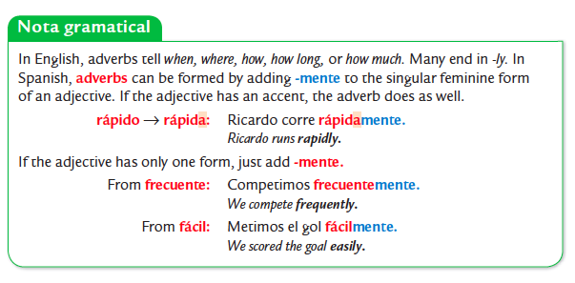

Pensar:
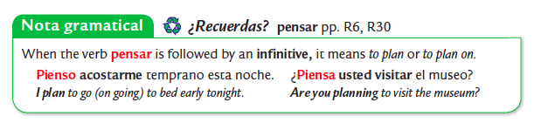
Demonstratives:
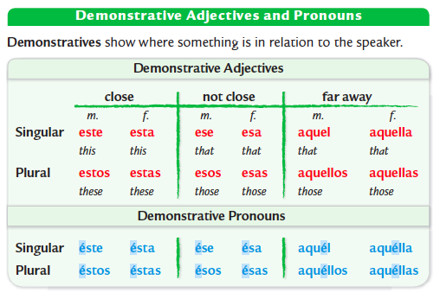

5. Cultura:
Please review your notes sheet on the cultural topics. While culture is not on the exam itself, it will be on a separate take-home quiz.
Datos generales y geográficos:
- The Atlantic Ocean borders Argentina to the east. Chile borders Argentina to the west. Paraguay, Uruguay and Bolivia are to the north.
- Buenos Aires is the capital of Argentina.
- Two important regions in Argentina are Pampas in the north Patagonia in the south.
- The peso argentino is the currency.

Información General
Patagonia:
- Patagonia is a region located in southern Argentina that is very popular with tourists looking for extreme sports.
- In Patagonia, you can kayak in the glaciers, camp, ski, go to the mountains, fly-fishing, sailing and do extreme sports. You can also see condors and penguins.

Vos:
- In Argentina, the Vos form is used instead of the tú form.
- Vos sos means tú eres and vos querés means you want.

La Boca:
- The Tango is a famous dance that originated in Argentina.
- La Boca is an old Buenos Aires neighborhood known for the arts with brightly painted houses. There you can see people dancing the tango, visit museums, buy handicrafts, and listen to singers.
- El Caminito is the most famous street in La Boca.

Los cantos deportivos:
- Real Madrid is a popular soccer team in Spain and River Plate is Argentina’s soccer team.
- Soccer fans are unified by cantos deportivos or sports chants in both Spain and Argentina.
- During games, soccer fans (aficionados) will sing cantos deportivos.

El arte:
Xul Solar:
- Xul Solar is known as a visionary and is a painter, sculptor, poet, and inventor that invented two poetic languages and some games.
- Xul Solar incorporated bright colors and images of the sun, the moon, and other geometric forms/shapes into the painting Bri País - Gente. His paintings often seem to represent other universes.

Antonio Berni:
- Antonio Berni’s paintings reflect life in Argentina.
- In Club Atlético Nueva Chicago you can see the importance of sport to young people in his representation of young boys in an Argentine barrio (neighborhood).

Las tiras cómicas:
- A well-known tira cómica or comic strip from Colombia is called Copetín.
- That comic strip is about a mischievous boy that lives in Bogotá, the capital of Colombia.
- Many people enjoy it for its ideas, unique characters, and humor.

La Copa Mundial:
- The first World Cup was in Uruguay in 1930.
- It was thought up by a French visionary named Jules Rimet, for whom the first trophy was named.
- The World Cup was interrupted by World War II between 1938 and 1950.
- There is a tournament every 4 years. The country of Brazil has won the most World Cup games.

Vivir de la tierra: (Living off the land)
Los cafeteros - Colombia:
- An important drink that Colombia produces is coffee. The beans grow in the mountains of Colombia because they are humid, tall, and cool.
- Cafeteros, or coffee works, wake up between 2 AM and 4AM.
- Cafeteros ride mules to work.

Los Gauchos - Argentina:
- Gauchos are ganaderos or cattle ranchers who live off the land in the region of La Pampa in Argentina.
- Gauchos are paid in the meat and skin of the cattle they care for.
- Gauchos typically wear large hats (to protect from the sun, wind and rain), pants called bambachas and tall boots.
- A typical Gaucho dish is asado which is a variety of meats.

