Nombre: _____________________________ Bloque: _____ Fecha: ______________________________

**Español 1 – Repaso de Unidad Preliminar**

**I. Overview. The following topics will be covered on the quiz/test:**

|  |  |
| --- | --- |
| * Greetings, Goodbyes * Introductions + Giving Names * Where you are from * Classroom vocabulary | * Alphabet * Weather * Days of Week + Dates * Telephone Numbers |

**II. Vocabulario.**

**A.** **Dibujos. Fill in the blank with the vocabulary word that matches the picture.**

1. 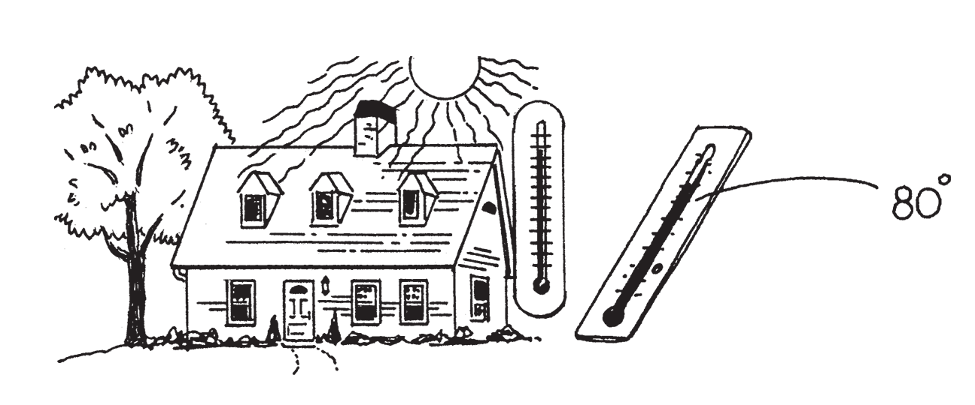 _______________________________________

2. 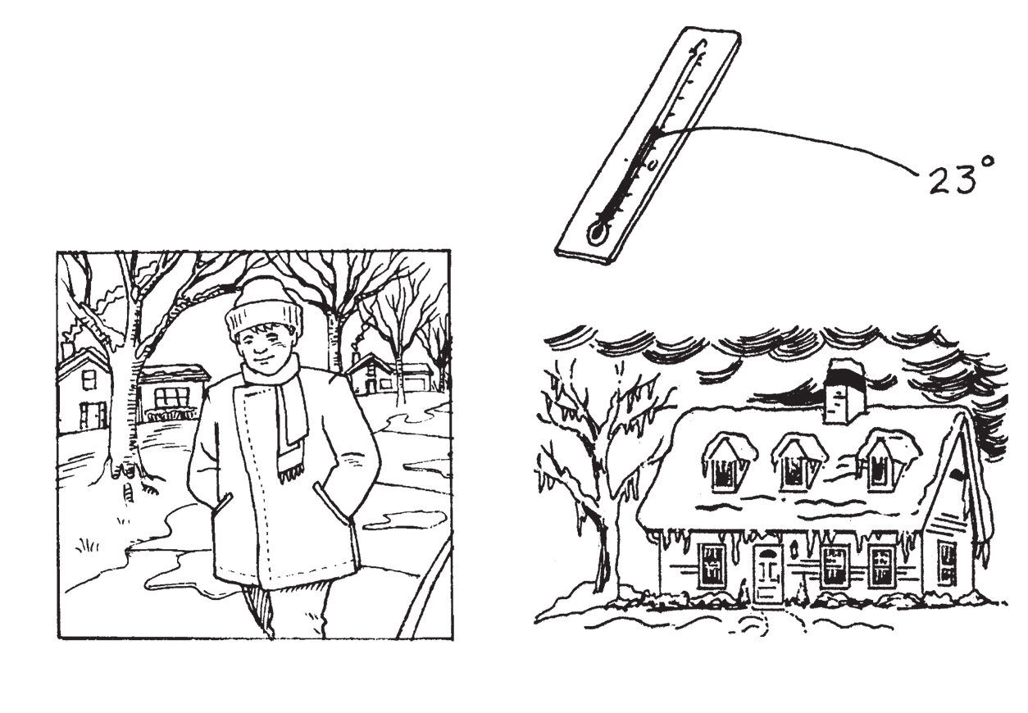_______________________________________

3. 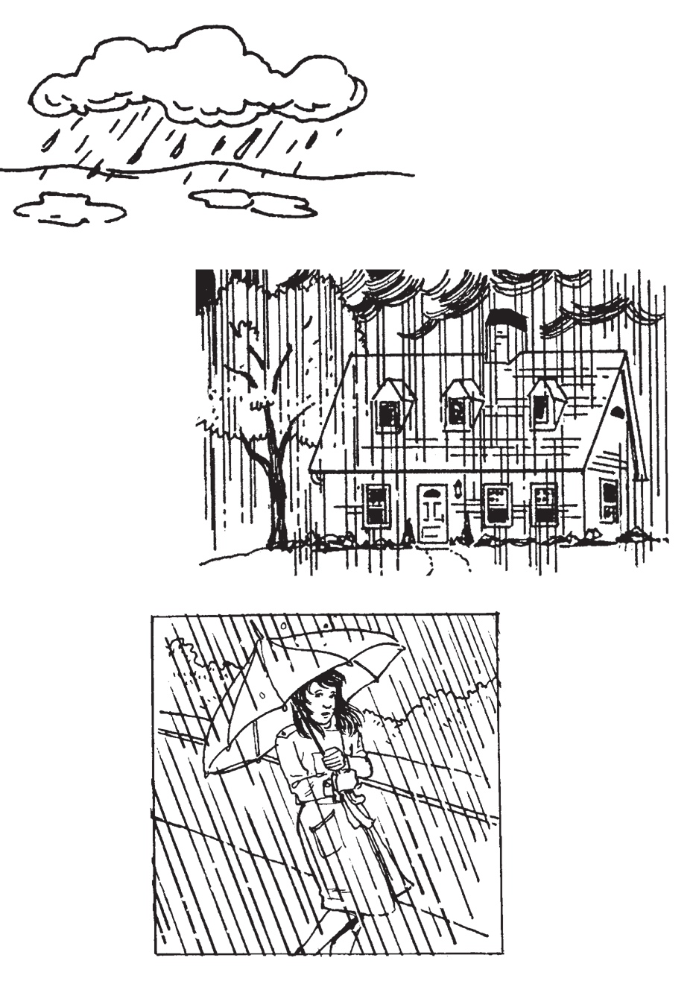_______________________________________

4. 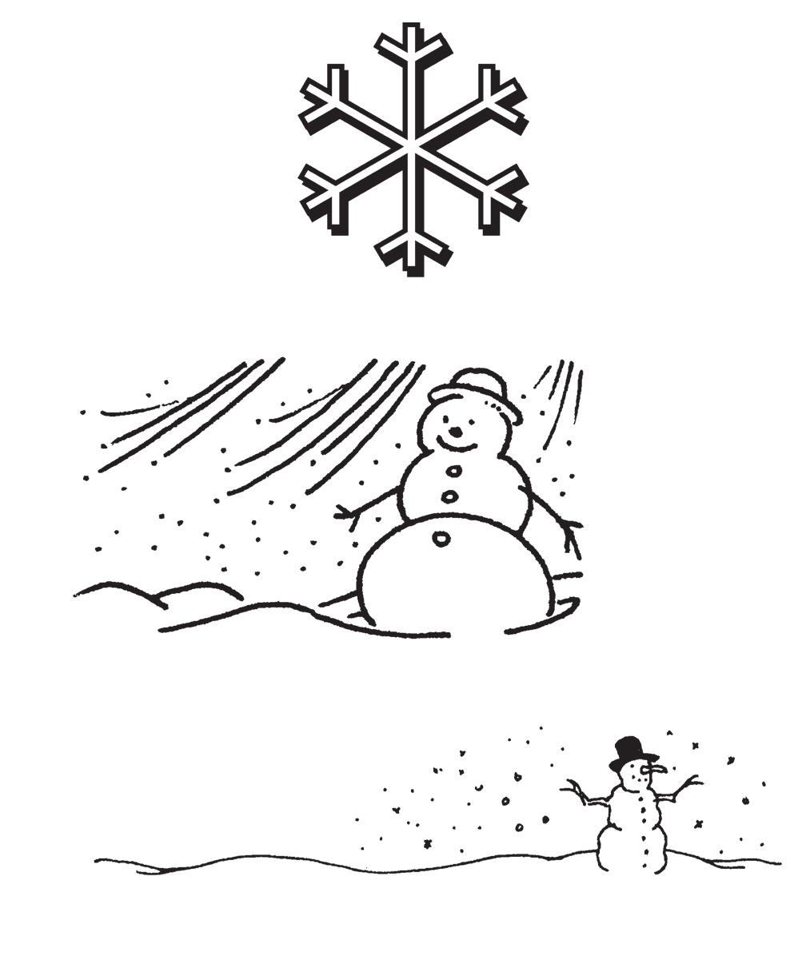_______________________________________

**B. Numbers. Write the missing number(s) in each sequence.**

1. uno, ______________, ______________, cuatro, cinco

2. dos, ______________, seis, ______________, diez, doce

3. tres, ______________, nueve, doce, quince

4. uno, ______________, cinco, ______________, nueve, once, trece

**C. Complete the sentences with the correct word.**

|  |
| --- |
| **presento mañana gusto dónde día** |

|  |  |
| --- | --- |
| 1. ¿Qué ____________________ es hoy?  2. Te ____________________ a Matilde.  3. ¿De ____________________ eres? | 4. Hasta ____________________.  5. Mucho ____________________. |

**D. Complete the conversation with the missing vocabulary words.**

**Susana:** Hola. ¿Cómo ____________________?

**Paco:** Buenos días. Estoy ______________________. ¿Y tú?

**Susana:** Muy bien, gracias. ¿ _______________________ te llamas?

**Paco:** Me _____________________ Paco. ¿Y tú?

**Susana:** Soy Susana. ¿De dónde __________________?

**Paco:** Soy de Costa Rica. ¿Y tú?

**Susana:** ________________ de México. ¿Cuál es tu _____________________ de teléfono?

**Paco:** Mi número de ______________________ es ocho-nueve-dos-tres-tres-uno-siete-siete-seis. ¿Me mandas un mensaje de texto mañana?

**Susana:** ¡Sí! Hasta luego.

**Paco:** ______________________.

**E. Write the following phone numbers in numerals.**

1. seis-nueve-siete cuatro-cero-dos-dos cinco-cinco-dos-uno ____________________________________

2. tres-uno-cero nueve-seis-siete ocho-ocho-uno-cinco ___________________________________________

**F.** **Identify each month pictured.**

1.  _____________________________________________
2.  _____________________________________________
3. Thanksgiving turkeyPilgrim emoji serving a turkey _____________________________________________
4.  _____________________________________________

**G. Write the following dates out in Spanish. Make sure to use the correct format!**

1. December 17th_____________________________________________

2. June 30th _____________________________________________

3. January 1st _____________________________________________

4. May 5th _____________________________________________

5. October 21st _____________________________________________

**H. Fill in the calendar with the month, days, and numbers IN SPANISH.**

|  |  |  |  |  |  |  |
| --- | --- | --- | --- | --- | --- | --- |
| *November* | | | | | | |
| *Sunday* | *Monday* | *Tuesday* | *Wednesday* | *Thursday* | *Friday* | *Saturday* |
| *1* | *2* | *3* | *4* | *5* | *6* | *7* |
| *8* | *9* | *10* | *11* | *12* | *13* | *14* |
| *15* | *16* | *17* | *18* | *19* | *20* | *21* |
| *22* | *23* | *24* | *25* | *26* | *27* | *28* |
| *29* | *30* | *31* |  |  |  |  |

**I. Fill in the blank with the correct answer to each question IN SPANISH.**

1. ¿Cómo te llamas? ___________________________________________________

2. ¿Qué pasa? ___________________________________________________

3. ¿De dónde eres? ___________________________________________________

4. ¿Qué día es hoy? ___________________________________________________

5. ¿Qué fecha es hoy? ___________________________________________________

6. ¿Cuál es tu número de teléfono? ___________________________________________________

**J. Match the classroom instructions with the illustrations that best correspond to them.**

**A. Girl raising her hand to answer a question. 
B. Boy closing a textbook.
C. Boy listening to music on a radio.
D. Boy opening up his backpack to take out homework.**

1. _____ Cierren los libros.

2. _____ Levanten la mano.

3. _____ Saquen una hoja de papel.

4. _____ Escucha.

**K. Select the letter of the best response for each question.**

1. ¿Cómo se dice book en español? a. Se escribe e-ese-pe-a-eñe-o-ele.

2. ¿Qué quiere decir maestro? b. Se dice libro.

3. ¿Tienen preguntas? c. Sí, ¿cómo se dice thank you?

4. ¿Cómo se escribe español? d. Quiere decir teacher.

**L. Use weather expressions to answer the following questions in complete sentences.**

1. ¿Qué tiempo hace en el invierno (the winter)? ________________________________________________

2. ¿Qué tiempo hace en el verano (the summer)? ________________________________________________

3. ¿Qué tiempo hace donde vives tú (where you live)? ____________________________________________

**III. Gramática.**

**A. Read the following sentences and write *Familiar* or *Formal* depending on whom they address.**

1. ¿Cómo está usted? _______________________

2. Señor Ortega, le presento a Ana Vega. _______________________

3. ¿Qué tal? ¿Cómo estás? _______________________

4. Te presento a Carolina. _______________________

5. Perdón. ¿Cómo se llama? _______________________

**B. Decide whether you would use *tú* or *usted* with each of the following people.**

1. Your little brother Miguel ____________________________

2. A customer who comes into your store ____________________________

3. The president of Argentina ____________________________

4. Pablo, a kid in your math class ____________________________

5. The principal of your school ____________________________

6. Mr. Gómez, your elderly neighbor ____________________________

**C. Verb llamar. Complete each sentence with the correct form of the verb.**

|  |
| --- |
| **Verb Bank:**  **llamas llamo llaman llama** |

1. ¿Como se _____ ellos?

2. Yo me llamo Helena, ¿cómo te _____ tú?

3. Por favor, señor, ¿cómo se _____ usted?

4. Mucho gusto, yo me _____ Daniel.

**IV. Lectura - Reading**

**A. Read the paragraph and answer the questions that follow.**

¡Hola! ¿Cómo estás? Me llamo Rogelio. Yo soy un muchacho de Puerto Rico. Soy estudiante en Colegio Juan Valderón. Mi mejor amigo es Jorge. Él es de Cuba. Nosotros somos compañeros de clase. Mi profesora de español es la señora Martínez. Ella es de México. Mi número de teléfono es uno-cuatro-cero – siete-nueve-cinco – dos-dos-seis-tres. Mi correo electrónico es RogelioRamon@gmail.com. ¡Hasta luego!

1. ¿Cómo se llama el muchacho? __________________________________________

2. ¿De dónde es Rogelio? __________________________________________________

3. ¿De dónde es Jorge? _____________________________________________________

4. ¿Quién es la profesora? ___________________________________________________

5. ¿De dónde es la profesora? ________________________________________________

6. ¿Cuál es el número de Rogelio? _____________________________________________

7. ¿Cuál es el correo electrónico de Rogelio? ______________________________________

8. ¿Quién es el amigo de Rogelio? _______________________________________________

**B. Read the conversation and answer the questions that follow.**

|  |  |
| --- | --- |
| **Alicia** | Hola. Yo soy Alicia. Yo soy tu compañera de clase. ¿Cómo te llamas? |
| **Miguel** | Me llamo Miguel. Mucho Gusto. |
| **Alicia** | Igualmente. |
| **Miguel** | ¿De dónde eres? |
| **Alicia** | Yo soy de Chile. ¿Y tú? |
| **Miguel** | Yo soy de Argentina. |
| **Alicia** | ¿Cuál es tu número? |
| **Miguel** | Es nueve-ocho-dos – tres-cinco-cinco – siete-cero-seis-cero |
| **Alicia** | Tengo que irme. Adiós. |
| **Miguel** | Hasta mañana. |

1. ¿Cómo se llama la muchacha? ______________________________________________

2. ¿Cómo se llama el muchacho? ______________________________________________

3. ¿De dónde es Alicia? ______________________________________________

4. ¿De dónde es Miguel? ______________________________________________

5. ¿Cuál es el número de Miguel? ______________________________________________

**V. Writing**

**A. Write a complete paragraph in Spanish.**

You need to introduce yourself and your best friend to the new student in class. Write a conversation that tells the following – include both questions and answers:

* Your name and your best friends name
* Where you are from
* How you are.
* Your telephone number
* The day, date, and time
* The name of your Spanish teacher.
* The weather today
* Introduce your best friend and give their name and where they are from.
* Say goodbye

__________________________________________________________________________________

__________________________________________________________________________________

__________________________________________________________________________________

__________________________________________________________________________________

__________________________________________________________________________________

__________________________________________________________________________________

__________________________________________________________________________________

__________________________________________________________________________________

__________________________________________________________________________________

__________________________________________________________________________________

__________________________________________________________________________________

__________________________________________________________________________________

__________________________________________________________________________________

__________________________________________________________________________________

__________________________________________________________________________________

__________________________________________________________________________________

__________________________________________________________________________________

__________________________________________________________________________________

__________________________________________________________________________________

__________________________________________________________________________________

__________________________________________________________________________________

__________________________________________________________________________________

__________________________________________________________________________________