Nombre: __________________________ Bloque: ____________ Fecha: ______________________
Español 1 – Unidad 5 – Guía de estudio
1. Temas:
- Irregular Yo verbs (dar and –GO verbs)
- Affirmative Tú Commands
- Ser vs Estar
- Talk about the layout and rooms of a house and the furniture and items in the house.
- Talk about planning a surprise birthday part.
- Talk about the chores you and others do.
- Culture of Ecuador

2. Partes del examen:
Speaking Test Section – 25%
For the speaking test you will receive a prompt in Spanish asking you to respond to a series of questions or provide specific information related to the themes covered in this unit. Your teacher will read the questions to you and you will respond in complete, detailed sentences in Spanish. You will be graded on the speaking rubric.

Listening Test Section – 25%
For the listening test, you will hear various styles of listening samples in Spanish related to the vocabulary and grammar from this unit. These samples can range from conversations, advertisements, sentences, and monologues to completing dictations. Then you will have to answer comprehension questions about what you heard. These questions may be true or false statements, fill-in-the-blank statements, short answer questions, or multiple-choice questions. The listening sections will be similar to what we have practiced in class.

Reading/Vocabulary Test Section – 25%
For the reading test, you will have to read various styles of reading samples in Spanish related to the vocabulary and grammar from this unit. These samples can range from written conversations, advertisements, sentences, and paragraphs to short stories. Then you will have to answer comprehension questions about what you heard. These questions may be true or false statements, fill-in-the-blank statements, short answer questions, true/false, or multiple-choice questions. The reading sections will be similar to what we have practiced in class and/or to the readings found in the book and workbook. You should also review the vocabulary list from the current unit and the notes from the current unit in preparation.

Writing Test Section – 25%
For the writing test, you will need to respond in Spanish to a given prompt. You may be asked to write an essay, write a short story, write a letter, create a written conversation, or provide another similar type of written piece. You should be prepared to write in essay form including an introduction, a conclusion, detailed supporting information, and you should make sure to have multiple, indented paragraphs. You will be graded on the writing rubric.

3. Vocabulario:
El apartamento | Apartment | Decorar | To decorate
El armario | Closet; armoire | La fiesta de sorpresa | Surprise party
Bajar | To descend | El globo | Balloon
La casa | House | Los invitados | Guests
La cocina | Kitchen | Invitar a | To invite (someone)
El comedor | Dining room | Salir | To leave; to go out
El cuarto | Room; bedroom | El secreto | Secret
La escalera | Stairs | Venir | To come (to a place)
Ideal | Ideal | Abrir | To open
El jardín (los jardines) | Garden | Buscar | To look for
El patio | Patio | Envolver (o-ue) | To wrap
El piso | Floor (of a building) | El papel de regalo | Wrapping paper
La planta baja | Ground floor | Recibir | To receive
La sala | Living room | El regalo | Gift; present
Subir | To go up | Traer | To bring
El suelo | Floor (of a room) | Acabar de… | To have just…
La alfombra | Rug | Ayudar | To help
La cama | Bed | Barrer el suelo | To sweep the floor
La cómoda | Dresser | Cocinar | To cook
Las cortinas | Curtains | Cortar el césped | To cut the grass/mow the lawn
El espejo | Mirror | Darle de comer al perro | To feed the dog
La lámpara | Lamp | Deber | Should; ought to
Los muebles | Furniture | Hacer la cama | To make the bed
El sillón (los sillones) | Armchair | Lavar los platos | To wash the dishes
El sofá | Sofa; couch | Limpiar (la cocina) | To clean (the kitchen)
La cosa | Thing | Limpio(a) | Clean
El disco compacto | Compact disc | Pasar la aspiradora | To vacuum
El lector DVD | DVD player | Planchar la ropa | To iron clothes
El radio | The radio | Poner la mesa | To set the table
El televisor | Television set | Los quehaceres | Chores
El tocadiscos compactos | CD player | Sacar la basura | To take out the trash
Los videojuegos | Video games | Sucio(a) | Dirty
Primero(a)/Primer/ (1˚/1 ª) | First (1st) | Decir | To say; to tell
Segundo(a)/ (2˚/2 ª) | Second (2nd) | Hay que | One has to; one must
Tercero(a)/Tercer / (3˚/3 ª) | Third (3rd) | Poner | To put; to place
Cuarto(a) / (4˚/4 ª) | Fourth (4th) | Si | If
Quinto(a) (5˚/5 ª) | Fifth (5th) | Todavía | Still; yet
Sexto(a) / (6˚/6 ª) | Sixth (6th) | El dormitorio; la habitación | Bedroom
Séptimo(a) / (7˚/7 ª) | Seventh (7th) | El cuarto de baño | The bathroom
Octavo(a) / (8˚/8 ª) | Eighth (8th) | El garaje | Garage
Noveno(a) / (9˚/9 ª) | Ninth (9th) | Las escaleras | Stairs
Décimo(a) / (10˚/10 ª) | Tenth (10th) | El telefóno celular (Lat. Amer) | Cellphone
Bailar | To dance | El teléfono móvil (Spain) | Cellphone
Cantar | To sing | El celular (Lat. America) | Cell
Celebrar | To celebrate | El móvil (Spain) | Cell
Dar una fiesta | To give/throw a party | La puerta | The door
Las decoraciones | Decorations

4. Gramática:
- Ser:
Yo soy | Nosotros(as) somos
Tú eres | Vosotros(as) sois
Usted es  Él/ella es | Ustedes son  Ellos/ellas son

- Estar:
Yo estoy | Nosotros(as) estamos
Tú estás | Vosotros(as) estáis
Usted está  Él/ella está | Ustedes están  Ellos/ellas están

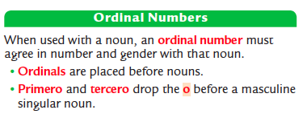
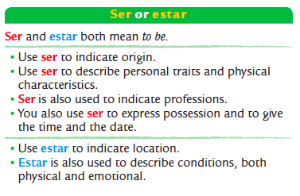

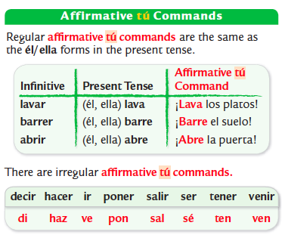
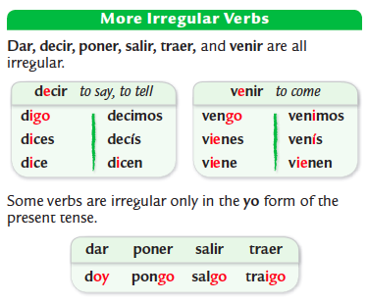

4. Cultura:
Please review your notes sheet on the cultural topics. While culture is not on the exam itself, it will be on a separate take-home quiz.

Información general:
- Quito is the capital of Ecuador.
- Español, Quechua, and other indigenous languages are spoken in Ecuador.
- Colors of the Ecuador flag: yellow, blue, red
- Julio Jaramillo was a famous Ecuadorian singer.
- Currency: Ecuador has used the US dollar since 2001.
- Ecuador is on the continent of South America.
- Peru is to the south.
- Colombia is to the north-east.
- The city of Otavalo is to the north of Quito.
- The Galapagos Islands are also governed by Ecuador.
- Ecuador is located on the line of the equator, from which it gets its name.

The Otavalo Indigenous Group:
- The painting, Las floristas, by Camilo Egas shows indigenous (native) women from Otavalo, Ecuador.
- The town of Otavalo, Ecuador is famous for its markets and textiles.
- The Otavalan women in the painting are wearing traditional clothing of white blouses and layered white and black skirts with red sashes.
- Camilo Egas, an Ecuadorian painter, has many paintings on display at Museo Nacional del Banco Central in Quito.
- Otavalo men have a traditional outfit of a blue poncho, white pants, a felt fedora, and a shimba which is a long braid.

More About the Otavalo People:
- The town of Otavalo, Ecuador is famous for its Saturday markets.
- The Otavalo indigenous group is famous worldwide for its textiles and have been weaving for centuries.
- Landscapes, animals, and geometric patterns are common designs of Otavalo weaving.
- The Otavalo people have found success with their markets and selling their artwork/textiles both locally and internationally.

The Ruins of Ingapirca:
- At Ingapirca, Ecuador, the Incans built El Templo del Sol which served as a fortress and place of worship.

El fútbol:
- The Selección Nacional is Ecuador's national team in the Copa Mundial (World Cup).

Fiestas de Quito:
- Quiteños (people from Quito) celebrate Fiestas de Quito on December 6th honoring the anniversary of the founding of Quito, Ecuador in 1534.
- The week long celebrations of Fiestas de Quito include parades, concerts and dances.
- During Fiestas de Quito, musical tributes or sereñatas quiteñas to the city of Quito.
- Other activities during the Fiestas de Quito include fireworks, beauty pageants (Reina de Quito), and building wooden race cars.

Casas de Ecuador:
- Traditional houses in Quito, Ecuador have elements of traditional Spanish architecture. They often have a white exterior and red-tiled roof.
- The Tigua artists are known for their colorful paintings created with chicken feather brushes on sheephide.
- The Tigua artists are from the Ecuadorian Andes.

The Andes Mountains & Cotopaxi Volcano:
- The world's highest active volcano is Cotopaxi near Quito, Ecuador.
- The Andes mountain range stretches north to south along the western coast of South America.
- More than 100 years ago Cotopaxi destroyed the nearby city of Latacunga, but it is not expected to erupt for many more decades.

Folkloric Dances:
Ecuador:
- Folkloric dances in Latin America represent a combination cultures and help form a national identity.
- A folkloric dance from Ecuador is the sanjuanito.
Panama:
- The national dance of Panama is the tamborito which combines African rhythms and Spanish and indigenous traditions.

Geographic Sites & the Equator:
- The equator devices the northern and southern hemispheres.
- The monument, La Mitad del Mundo (The Middle of the World) in Ecuador, marks the location of equator, where you can stand in both hemispheres.
- Ushuaia, in Tierra del Fuego, Argentina is known as La ciudad del fin del mundo (the city at the end of the earth). It is the southern-most city in the world.

